**UNIT II**

**BIPOLAR JUNCTION TRANSISTOR**

## INTRODUCTION

A bipolar junction transistor (BJT) is a three terminal device in which operation depends on the interaction of both majority and minority carriers and hence the name bipolar. The BJT is analogues to vacuum triode and is comparatively smaller in size. It is used as amplifier and oscillator circuits, and as a switch in digital circuits. It has wide applications in computers, satellites and other modern communication systems.

## CONSTRUCTION OF BJT AND ITS SYMBOLS

The **Bipolar Transistor** basic construction consists of two PN-junctions producing three connecting terminals with each terminal being given a name to identify it from the other two. These three terminals are known and labeled as the Emitter ( E ), the Base ( B ) and the Collector ( C ) respectively. There are two basic types of bipolar transistor construction, PNP and NPN, which basically describes the physical arrangement of the P-type and N-type semiconductor materials from which they are made.

Transistors are three terminal active devices made from different semiconductor materials that can act as either an insulator or a conductor by the application of a small signal voltage. The transistor's ability to change between these two states enables it to have two basic functions: "switching" (digital electronics) or "amplification" (analogue electronics). Then bipolar transistors have the ability to operate within three different regions:

* 1. Active Region - the transistor operates as an amplifier and Ic = β.Ib
* 2. Saturation - the transistor is "fully-ON" operating as a switch and Ic = I(saturation)
* 3. Cut-off - the transistor is "fully-OFF" operating as a switch and Ic = 0

Bipolar Transistors are current regulating devices that control the amount of current flowing through them in proportion to the amount of biasing voltage applied to their base terminal acting like a current-controlled switch. The principle of operation of the two transistor types PNP and NPN, is exactly the same the only difference being in their biasing and the polarity of the power supply for each type(fig 1).

#### Bipolar Transistor Construction

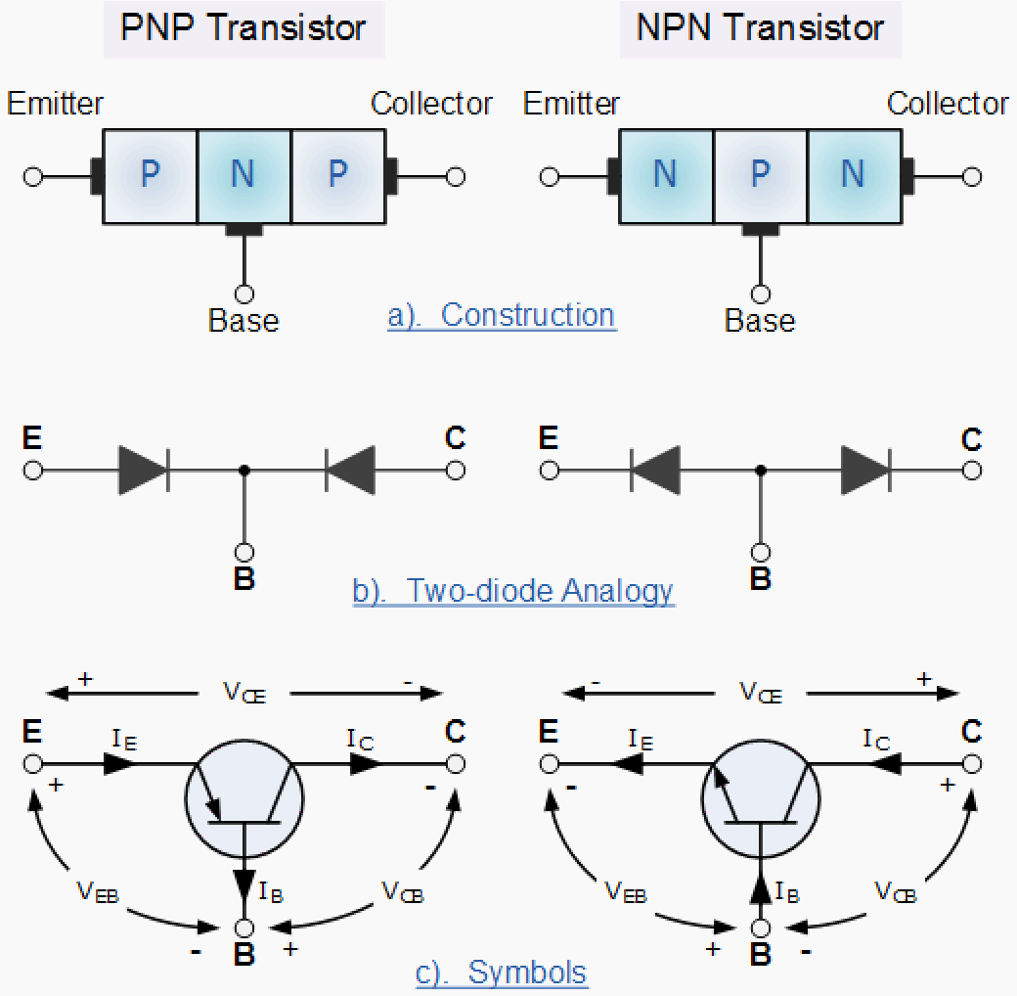

Fig Bipolar Junction Transistor Symbol

The construction and circuit symbols for both the PNP and NPN bipolar transistor are given above with the arrow in the circuit symbol always showing the direction of "conventional current flow" between the base terminal and its emitter terminal. The direction of the arrow always points from the positive P-type region to the negative N-type region for both transistor types, exactly the same as for the standard diode symbol.

#### TRANSISTOR CURRENT COMPONENTS:

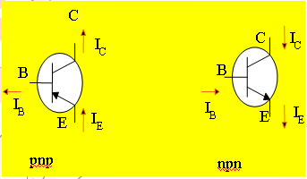

Fig Bipolar Junction Transistor Current Components

The above fig 3.2 shows the various current components, which flow across the forward biased emitter junction and reverse- biased collector junction. The emitter current IE consists of hole current IPE (holes crossing from emitter into base) and electron current InE (electrons crossing from base into emitter).The ratio of hole to electron currents, IpE / InE , crossing the emitter junction is proportional to the ratio of the conductivity of the p material to that of the n material. In a transistor, the doping of that of the emitter is made much larger than the doping of the base. This feature ensures (in p-n-p transistor) that the emitter current consists an almost entirely of holes. Such a situation is desired since the current which results from electrons crossing the emitter junction from base to emitter do not contribute carriers, which can reach the collector.

Not all the holes crossing the emitter junction JE reach the the collector junction JC

Because some of them combine with the electrons in n-type base. If IpC is hole current at junction JC there must be a bulk recombination current ( IPE- IpC ) leaving the base.

Actually, electrons enter the base region through the base lead to supply those charges, which have been lost by recombination with the holes injected in to the base across JE. If the emitter were open circuited so that IE=0 then IpC would be zero. Under these circumstances, the base and collector current IC would equal the reverse saturation current ICO. If IE≠0 then

IC= ICO- IpC

For a p-n-p transistor, ICO consists of holes moving across JC from left to right (base to collector) and electrons crossing JC in opposite direction. Assumed referenced direction for ICO i.e. from right to left, then for a p-n-p transistor, ICO is negative. For an n-p-n transistor, ICO is positive.The basic operation will be described using the pnp transistor. The operation of the pnp transistor is exactly the same if the roles played by the electron and hole are interchanged.

One p-n junction of a transistor is reverse-biased, whereas the other is forward-biased.

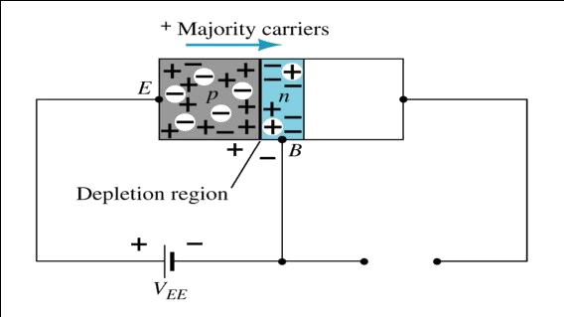

a Forward-biased junction of a pnp transistor

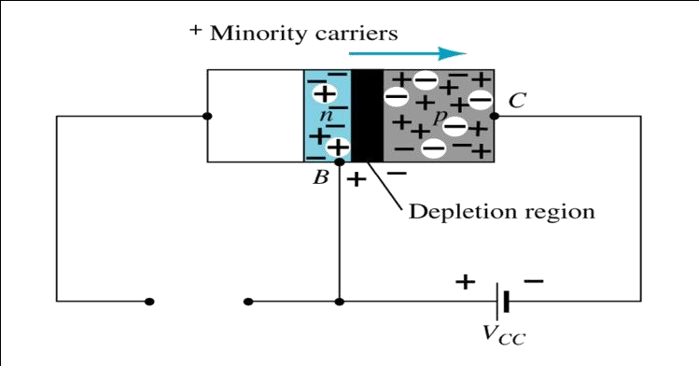

b Reverse-biased junction of a pnp transistor

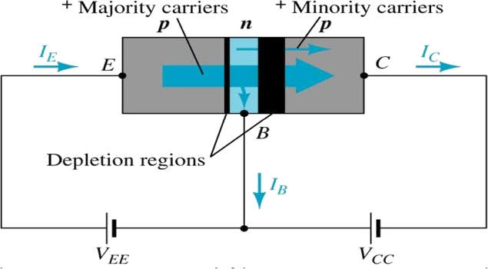

c Both biasing potentials have been applied to a pnp transistor and resulting majority and minority carrier flows indicated.

Majority carriers (+) will diffuse across the forward-biased p-n junction into the n-type material.

A very small number of carriers (+) will through n-type material to the base terminal. Resulting IB is typically in order of microamperes.

The large number of majority carriers will diffuse across the reverse-biased junction into the p-type material connected to the collector terminal

Applying KCL to the transistor :

*IE = IC + IB*

The comprises of two components – the majority and minority carriers

*IC = ICmajority + ICOminority*

*ICO – IC* current with emitter terminal open and is called leakage current Various parameters which relate the current components is given below **Emitter efficiency:**

**  *currentofinjectedcar riersatJ E*

*totalemitt ercurrent*

**  *I PE*

*I pE*  *InE*

 *I pE*

*InE*

#### Transport Factor:

** \*  *injectedca rriercurrentreachingJC*

*injectedca rrierncurrentatJ E*

** \*  *I pC*

*InE*

#### Large signal current gain:

The ratio of the negative of collector current increment to the emitter current change from zero (cut- off)to IE the large signal current gain of a common base transistor.

**   (*IC*  *ICO* )

*I E*

Since IC and IE have opposite signs, then α, as defined, is always positive. Typically numerical values of α lies in the range of 0.90 to 0.995

**  *I pC*  *I pC* \* *I pE*

*I E InE*

*I E *  ** \***

The transistor alpha is the product of the transport factor and the emitter efficiency. This statement assumes that the collector multiplication ratio ** \* is unity. ** \* is the ratio of total current crossing JC to hole arriving at the junction.

## Bipolar Transistor Configurations

As the **Bipolar Transistor** is a three terminal device, there are basically three possible ways to connect it within an electronic circuit with one terminal being common to both the input and output. Each method of connection responding differently to its input signal within a circuit as the static characteristics of the transistor vary with each circuit arrangement.

* 1. Common Base Configuration - has Voltage Gain but no Current Gain.
* 2 Common Emitter Configuration - has both Current and Voltage Gain.
* 3. Common Collector Configuration - has Current Gain but no Voltage Gain.

## COMMON-BASE CONFIGURATION

Common-base terminology is derived from the fact that the : base is common to both input and output of t configuration. base is usually the terminal closest to or at ground potential. Majority carriers can cross the reverse-biased junction because the injected majority carriers will appear as minority carriers in the n-type material. All current directions will refer to conventional (hole) flow and the arrows in all electronic symbols have a direction defined by this convention.

Note that the applied biasing (voltage sources) are such as to establish current in the direction indicated for each branch.

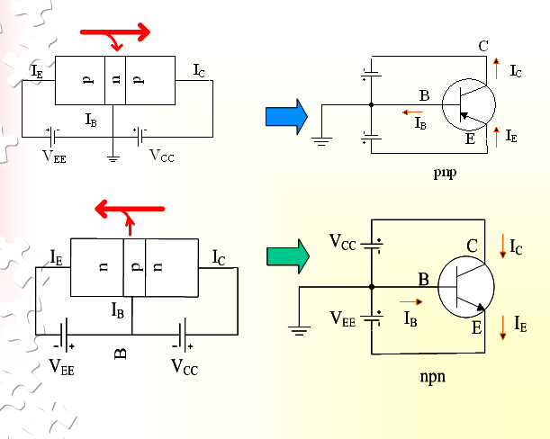

Fig CB Configuration

To describe the behavior of common-base amplifiers requires two set of characteristics:

* + 1. Input or driving point characteristics.
    2. Output or collector characteristics

The output characteristics has 3 basic regions:

* + Active region –defined by the biasing arrangements
  + Cutoff region – region where the collector current is 0A
  + Saturation region- region of the characteristics to the left of VCB = 0V

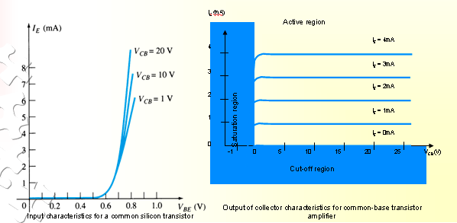

Fig CB Input-Output Characteristics

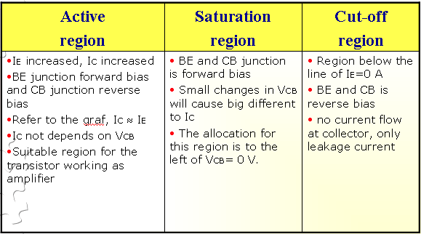

The curves (output characteristics) clearly indicate that a first approximation to the relationship between IE and IC in the active region is given by

IC ≈IE

Once a transistor is in the ‘on’ state, the base-emitter voltage will be assumed to beVBE = 0.7V

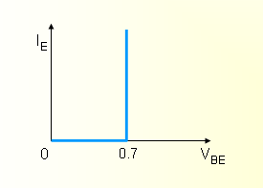

In the dc mode the level of IC and IE due to the majority carriers are related by a quantity called alpha

= αdc

IC = IE + ICBO

It can then be summarize to IC = IE (ignore ICBO due to small value)

For ac situations where the point of operation moves on the characteristics curve, an ac alpha defined by αac

Alpha a common base current gain factor that shows the efficiency by calculating the current percent from current flow from emitter to collector. The value of  is typical from 0.9 ~ 0.998.

**Biasing:**Proper biasing CB configuration in active region by approximation IC  IE (IB  0 uA)

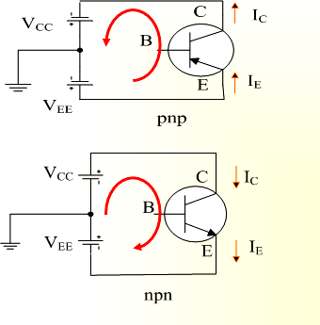

Fig CE Configuration

## TRANSISTOR AS AN AMPLIFIER



Fig Basic Transistor Amplifier Circuit

#### Common-Emitter Configuration

It is called common-emitter configuration since : emitter is common or reference to both input and output terminals.emitter is usually the terminal closest to or at ground potential.

Almost amplifier design is using connection of CE due to the high gain for current and voltage.

Two set of characteristics are necessary to describe the behavior for CE ;input (base terminal) and output (collector terminal) parameters.

Proper Biasing common-emitter configuration in active region

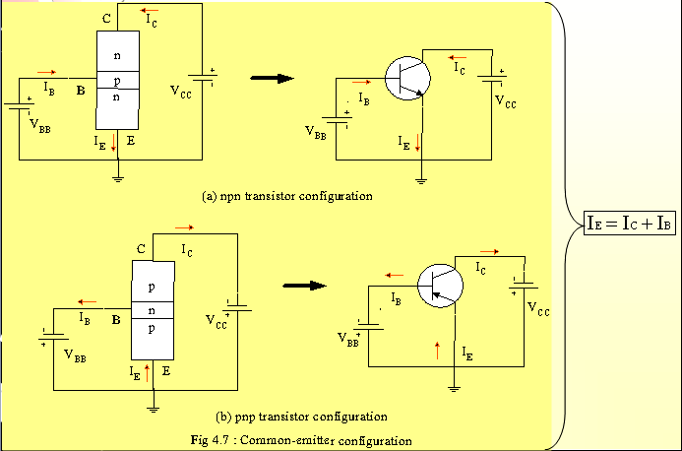

Fig CE Configuration

IB is microamperes compared to miliamperes of IC.

IB will flow when VBE > 0.7V for silicon and 0.3V for germanium Before this value IB is very small and no IB.

Base-emitter junction is forward bias Increasing VCE will reduce IB for different values.

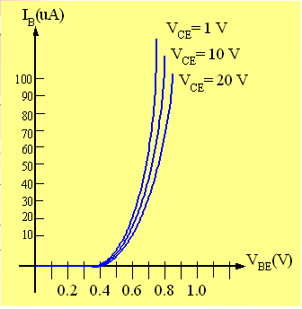

Fig a Input characteristics for common-emitter npn transistor

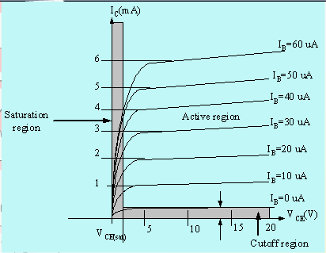

Fig b Output characteristics for common-emitter npn transistor

For small VCE (VCE < VCESAT, IC increase linearly with increasing of VCE VCE > VCESAT IC not totally depends on VCE → constant IC

IB(uA) is very small compare to IC (mA). Small increase in IB cause big increase in IC IB=0 A → ICEO occur.

Noticing the value when IC=0A. There is still some value of current flows.

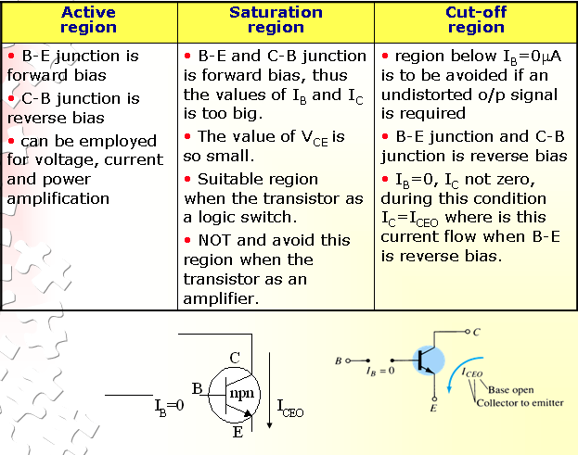

#### Beta () or amplification factor

The ratio of dc collector current (IC) to the dc base current (IB) is dc beta (dc ) which is dc current gain where IC and IB are determined at a particular operating point, Q-point (quiescent point). It’s define by the following equation:

30 < dc < 300 → 2N3904

On data sheet, dc=*hfe* with *h* is derived from ac hybrid equivalent cct. FE are derived from forward- current amplification and common-emitter configuration respectively.

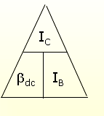

For ac conditions, an ac beta has been defined as the changes of collector current (IC) compared to the changes of base current (IB) where IC and IB are determined at operating point. On data sheet,

ac=*hfe* It can defined by the following equation:

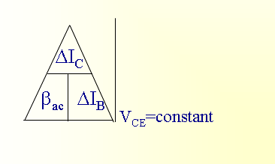

From output characteristics of commonemitter configuration, find ac and dc with an Operating point at IB=25 A and VCE =7.5V

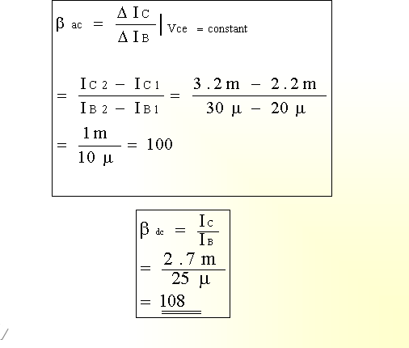

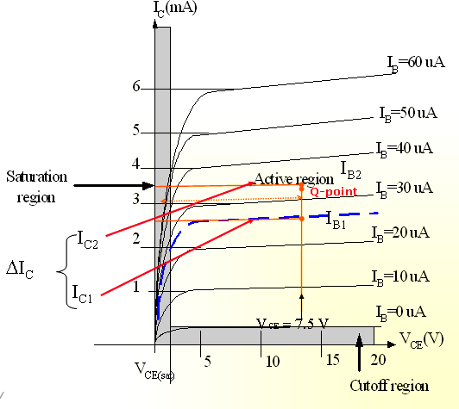

#### Relationship analysis between α and β

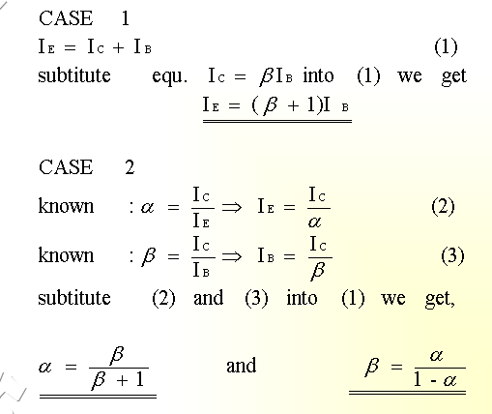

**COMMON – COLLECTOR CONFIGURATION**

Also called emitter-follower (EF). It is called common-emitter configuration since both the signal source and the load share the collector terminal as a common connection point.The output voltage is obtained at emitter terminal. The input characteristic of common-collector configuration is

similar with common-emitter. configuration.Common-collector circuit configuration is provided with the load resistor connected from emitter to ground. It is used primarily for impedance- matching purpose since it has high input impedance and low output impedance.

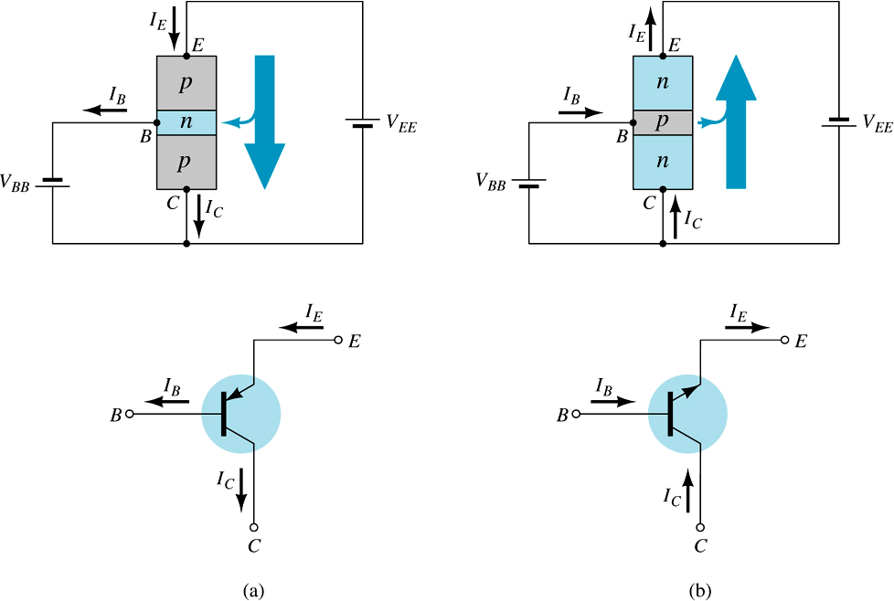

Fig CC Configuration

For the common-collector configuration, the output characteristics are a plot of IE vs VCE for a range

of values of IB.

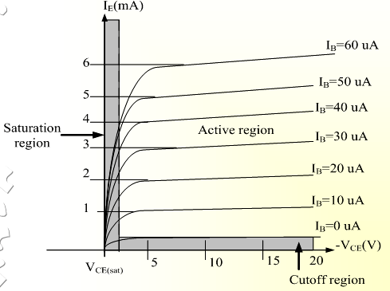

Fig Output Characteristics of CC Configuration for npn Transistor

#### Limits of opearation

Many BJT transistor used as an amplifier. Thus it is important to notice the limits of operations.At least 3 maximum values is mentioned in data sheet.

There are:

1. Maximum power dissipation at collector: PCmax or PD
2. Maximum collector-emitter voltage: VCEmax sometimes named as VBR(CEO) or VCEO.
3. Maximum collector current: ICmax

There are few rules that need to be followed for BJT transistor used as an amplifier. The rules are: transistor need to be operate in active region!

IC < ICmax PC < PCmax

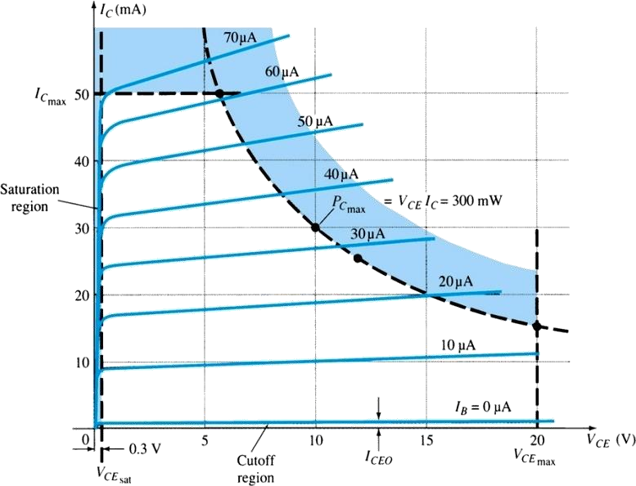

Note: VCE is at maximum and IC is at minimum (ICMAX=ICEO) in the cutoff region. IC is at maximum and VCE is at minimum (VCE max = Vcesat = VCEO) in the saturation region. The transistor

operates in the active region between saturation and cutoff.

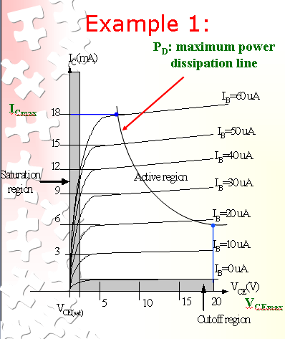

Refer to the fig. Example; A derating factor of 2mW/°C indicates the power dissipation is reduced 2mW each degree centigrade increase of temperature.

*Step1:*

The maximum collector power dissipation,

**PD=ICMAX x VCEmax**= 18m x 20 = 360 mW

*Step 2:*

At any point on the characteristics the product of and must be equal to 360 mW. Ex. 1. If choose ICmax= 5 mA, substitute into the (1), we get

VCEmaxICmax= 360 mW VCEmax(5 m)=360/5=7.2 V

Ex.2. If choose VCEmax=18 V, substitute into (1), we get VCEmaxICmax= 360 mW

(10) ICMAX=360m/18=20 mA

#### Derating PDmax

PDMAX is usually specified at 25°C.

The higher temperature goes, the less is PDMAX

Example;A derating factor of 2mW/°C indicates the power dissipation is reduced 2mW each degree centigrade increase of temperature.

**NEED FOR TRANSISTOR BIASING**

**Operating Point**

If the o/p signal must be a faithful reproduction of the i/p signal, the transistor must be operated in active region. That means an operating point has to be established in this region . To establish an operating point (proper values of collector current Ic and collector to emitter voltage VCE) appropriate supply voltages and resistances must be suitably chosen in the ckt. This process of selecting proper supply voltages and resistance for obtaining desired operating point or Q point is called as biasing and the ckt used for transistor biasing is called as biasing ckt.

There are four conditions to be met by a transistor so that it acts as a faithful ampr:

* + 1. Emitter base junction must be forward biased (VBE=0.7Vfor Si, 0.2V for Ge) and collector base junction must be reverse biased for all levels of i/p signal.
    2. Vce voltage should not fall below VCE (sat) (0.3V for Si, 0.1V for Ge) for any part of the i/p signal. For VCE less than VCE (sat) the collector base junction is not probably reverse biased.
    3. The value of the signal Ic when no signal is applied should be at least equal to the max. collector current t due to signal alone.
    4. Max. rating of the transistor Ic(max), VCE (max) and PD(max) should not be exceeded at any value of i/p signal.

Consider the fig shown in fig1. If operating point is selected at A, A represents a condition when no bias is applied to the transistor i.e, Ic=0, VCE =0. It does not satisfy the above said conditions necessary for faithful amplification.

Point C is too close to PD(max) curve of the transistor. Therefore the o/p voltage swing in the positive direction is limited.

Point B is located in the middle of active region .It will allow both positive and negative half cycles in the o/p signal. It also provides linear gain and larger possible o/p voltages and currents

Hence operating point for a transistor amplifier is selected to be in the middle of active region.

IC(max)

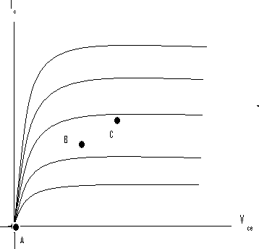

PD(max)

Vce(sat)

Fig 4.1CE Output Characteristics

* 1. **DC LOAD LINE**

Referring to the biasing circuit of fig 4.2a, the values of VCC and RC are fixed and Ic and VCE are dependent on RB.

Applying Kirchhoff’s voltage law to the collector circuit in fig. 4.2a, we get

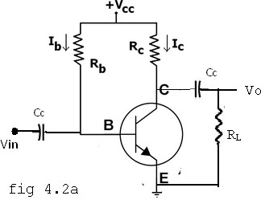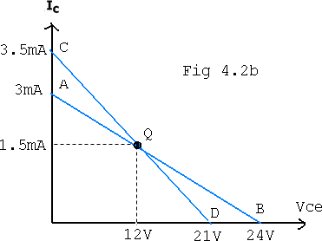

Fig 4.2a CE Amplifier circuit (b) Load line

The straight line represented by AB in fig4.2b is called the dc load line. The coordinates of the end point A are obtained by substituting VCE =0 in the above equation. Then . Therefore The coordinates of A are VCE =0 and .

The coordinates of B are obtained by substituting Ic=0 in the above equation. Then Vce = Vcc. Therefore the coordinates of B are VCE =Vcc and Ic=0. Thus the dc load line AB can be drawn if the values of Rc and Vcc are known.

As shown in the fig4.2b, the optimum POINT IS LOCATED AT THE MID POINT OF THE MIDWAY BETWEEN a AND b. In order to get faithful amplification, the Q point must be well within the active region of the transistor.

Even though the Q point is fixed properly, it is very important to ensure that the operating point remains stable where it is originally fixed. If the Q point shifts nearer to either A or B, the output voltage and current get clipped, thereby o/p signal is distorted.

In practice, the Q-point tends to shift its position due to any or all of the following three main factors.

* + 1. Reverse saturation current, Ico, which doubles for every 10oC raise in temperature
    2. Base emitter Voltage ,VBE, which decreases by 2.5 mV per oC
    3. Transistor current gain, hFE or β which increases with temperature.

If base current IB is kept constant since IB is approximately equal to Vcc/RB. If the transistor is replaced by another one of the same type, one cannot ensure that the new transistor will have identical parameters as that of the first one. Parameters such as β vary over a range. This results in the variation of collector current Ic for a given IB. Hence , in the o/p characteristics, the spacing between the curves might increase or decrease which leads to the shifting of the Q-point to a location which might be completely unsatisfactory.

### **AC LOAD LINE**

After drawing the dc load line, the operating point Q is properly located at the center of the dc load line. This operating point is chosen under zero input signal condition of the circuit. Hence the ac load line should also pas through the operating point Q. The effective ac load resistance Rac, is a combination of RC parallel to RL i.e. || . So the slope of the ac load line CQD will be . To draw the ac load line, two end points, I.e. VCE(max) and IC(max) when the signal is applied are required.

, which locates point D on the Vce axis.

, which locates the point C on the IC axis.

By joining points c and D, ac load line CD is constructed. As RC > Rac, The dc load line is less steep than ac load line.

### **STABILITY FACTOR (S):**

The rise of temperature results in increase in the value of transistor gain β and the leakage current Ico. So, IC also increases which results in a shift in operating point. Therefore, The biasing network should be provided with thermal stability. Maintenance of the operating point is specified by S, which indicates the degree of change in operating point due to change in temperature.

The extent to which IC is stabilized with varying IC is measured by a stability factor S

  ,

For CE configuration 

Differentiate the above equation w.r.t IC , We get



S should be small to have better thermal stability.

#### Stability factor S’ and S’’:

S’ is defined as the rate of change of IC with VBE, keeping IC and VBE constant.



S’’ is defined as the rate of change of IC with β, keeping ICO and VBE constant.



#### VOLTAGE DIVIDER BIAS OR SELF BIAS OR EMITTER BIAS

The voltage divider as shown in the fig 4.7 is formed using external resistors R1 and R2. The voltage across R2 forward biases the emitter junction. By proper selection of resistors R1 and R2, the operating point of the transistor can be made independent of β. In this circuit, the voltage divider holds the base voltage fixed independent of base current provided the divider current is large compared to the base current. However, even with a fixed base voltage, collector current varies with temperature (for example) so an emitter resistor is added to stabilize the Q-point, similar to the above circuits with emitter resistor.

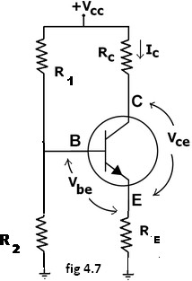

Fig 4.7 Voltage Divider Biasing Circuit

In this circuit the base voltage is given by:

V_B = \ voltage across



\approx V_{cc} \frac{R_2}{(R_1+R_2)}I_B << I_2 = V_B / R_2 \ provided .

Also V_B = V_{be} + I_ER_E \ 

For the given circuit,

 I_B =\frac  {  \frac  {V_{CC}}{1+R_1/R_2}  - V_{be} } {( \beta + 1)R_E + R_1 \parallel R_2 } .

q7_clip_image002Let the current in resistor R1 is I1 and this is divided into two parts – current through base and resistor R2. Since the base current is very small so for all practical purpose it is assumed that I1 also flows through R2, so we have

q7_clip_image004

Applying KVL in the circuit, we have

q7_clip_image002_0000q7_clip_image004_0000

q7_clip_image008q7_clip_image006

q7_clip_image010

It is apparent from above expression that the collector current is independent of ? thus the stability is excellent. In all practical cases the value of VBE is quite small in comparison to the V2, so it can be ignored in the above expression so the collector current is almost independent of the transistor parameters thus this arrangement provides excellent stability.

Again applying KVL in collector circuit, we have

q7_clip_image002_0001q7_clip_image004_0001q7_clip_image006_0000q7_clip_image008_0000

The resistor RE provides stability to the circuit. If the current through the collector rises, the voltage across the resistor RE also rises. This will cause VCE to increase as the voltage V2 is independent of collector current. This decreases the base current, thus collector current increases to its former value.

q7_clip_image002_0002Stability factor for such circuit arrangement is given by

q7_clip_image004_0002

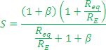

If Req/RE is very small compared to 1, it can be ignored in the above expression thus we have

q7_clip_image008_0001

Which is excellent since it is the smallest possible value for the stability. In actual practice the value of stability factor is around 8-10, since Req/RE cannot be ignored as compared to 1.

#### Merits:

* + Unlike above circuits, only one dc supply is necessary.
  + Operating point is almost independent of β variation.
  + Operating point stabilized against shift in temperature.

#### Demerits:

* + In this circuit, to keep IC independent of β the following condition must be met:

I_C = \beta I_B = \beta \frac  {   \frac  {V_{CC}}{1+R_1/R_2}  - V_{be} } {( \beta + 1)R_E + R_1 \parallel R_2 } \approx \frac  { \frac {V_{CC}}{1+R_1/R_2}- V_{be}} {R_E} , 

which is approximately the case if ( \beta + 1 ) R_E >> R_1 \parallel R_2

where R1 || R2 denotes the equivalent resistance of R1 and R2 connected in parallel.

* + As β-value is fixed for a given transistor, this relation can be satisfied either by keeping RE fairly large, or making R1||R2 very low.
  + If RE is of large value, high VCC is necessary. This increases cost as well as precautions necessary while handling.
  + If R1 || R2 is low, either R1 is low, or R2 is low, or both are low. A low R1 raises VB closer to VC, reducing the available swing in collector voltage, and limiting how large RC can be made without driving the transistor out of active mode. A low R2 lowers Vbe, reducing the allowed collector current. Lowering both resistor values draws more current from the power supply and lowers the input resistance of the amplifier as seen from the base.
  + AC as well as DC feedback is caused by RE, which reduces the AC voltage gain of the amplifier. A method to avoid AC feedback while retaining DC feedback is discussed below.

**Usage:** The circuit's stability and merits as above make it widely used for linear circuits.

## THERMAL RUNAWAY AND THERMAL STABILITY

#### THERMAL RUNAWAY:

The collector current for the CE circuit is given by  The three variables in the equation, β, , and  increases with rise in temperature. In particular, the reverse saturation current or leakage current  changes greatly with temperature. Specifically it doubles for every 10oC rise in temperature. The collector current causes the collector base junction temperature to rise which in turn, increase  , as a result  will increase still further, which will further rise the

temperature at the collector base junction. This process will become cumulative leading at the collector base junction. This process will become cumulative leading to *“thermal runaway”*. Consequently, the ratings of the transistor are exceeded which may destroy the transistor itself.

The collector is made larger in size than the emitter in order to help the heat developed at the collector junction. However if the circuit is designed such that the base current  is made to decrease automatically with rise in temperature, then the decrease in  will compensate for increase in the

 , keeping  almost constant.

#### THERMAL RESISTANCE

Consider transistor used in a circuit where the ambient temperature of the air around the transistor is TAoC and the temperature of the collector-base junction of the transistor is T oC.

J

Due to heating within the transistor TJ is higher than TA. As the temperature difference TJ- TA is greater, the power dissipated in the transistor, PD will be greater, i.e, TJ- TA PD

The equation can be written as TJ- TA PD. , where is the constant of proportionality and is called the Thermal resistance. Rearranging the above equation = TJ- TA /PD. Hence is measured in



oC/W which may be as small as 0.2 oC/W for a high power transistor that has an efficient heat sink or up to 1000oC/W for small signal, low power transistor which have no cooling provision.

As Θ represents total thermal resistance from a transistor junction to the ambient temperature, it is referred to as ΘJ-A. However, for power transistors, thermal resistance is given form junction to case, ΘJ-C.

The amount resistance from junction to ambience is considered to consist of 2 parts.

ΘJ-A = ΘJ-C - ΘC-A.

Which indicates the heat dissipated in the junction must make its way to the surrounding air through two series paths from junction to case and from case to air. Hence the power dissipated.

PD = (TJ- TA Θ J-A

=(TJ- TA Θ J-C + Θ C-A)

ΘJ-C is determined by the type of manufacture of the transistor and how it is located I the case, but ΘC-A is determined by the surface area of the case or flange and its contact with air. If the effective surface area of the transistor case could be increased, the resistance to heat flows, or could be increased ΘC-A, could be decreased. This can be achieved by the use of a heat sink.

The heat sink is a relatively large, finned, usually black metallic heat conducting device in close contact with transistor case or flange. Many versions of heat sink exist depending upon the shape and size of the transistor. Larger the heat sink smaller is the thermal resistance ΘHS-A.

This thermal resistance is not added to ΘC-A in series, but is instead in parallel with it and if

ΘHS-A is much less than ΘC-A, then ΘC-A will be reduced significantly, thereby improving the dissipation capability of the transistor. Thus

Θ J-A =Θ J-C + Θ C-A|| ΘHS-A.

## CONDITION FOR THERMAL STABILITY

For preventing thermal runaway, the required condition I the rate at which the heat is released at the collector junction should not exceed the rate at which the heat can be dissipated under steady state condition. Hence the condition to be satisfied to avoid thermal runaway is given by



If the circuit is properly designed, then the transistor cannot runaway below a specified ambient temperature or even under any conditions.

In the self biased circuit the transistor is biased in the active region. The power generated at the junction without any signal is



Let us assume that the quiescent collector and the emitter currents are equal. Then

………………….(1)

The condition to prevent thermal runaway can be written as



As Θ and  are positive,  should be negative in order to satisfy the above condition. Differentiating equation (1) w.r.t  we get

Hence to avoid thermal runaway it is necessary that



## Emitter Follower

Emitter follower circuit has a prominent place in feedback amplifiers. Emitter follower is a case of negative current feedback circuit. This is mostly used as a last stage amplifier in signal generator circuits.

The important features of Emitter Follower are −

* It has high input impedance
* It has low output impedance
* It is ideal circuit for impedance matching

All these ideal features allow many applications for the emitter follower circuit. This is a current amplifier circuit that has no voltage gain.

### **Construction**

The constructional details of an emitter follower circuit are nearly similar to a normal amplifier. The main difference is that the load RL is absent at the collector terminal, but present at the emitter terminal of the circuit. Thus the output is taken from the emitter terminal instead of collector terminal.

The biasing is provided either by base resistor method or by potential divider method. The following figure shows the circuit diagram of an Emitter Follower.

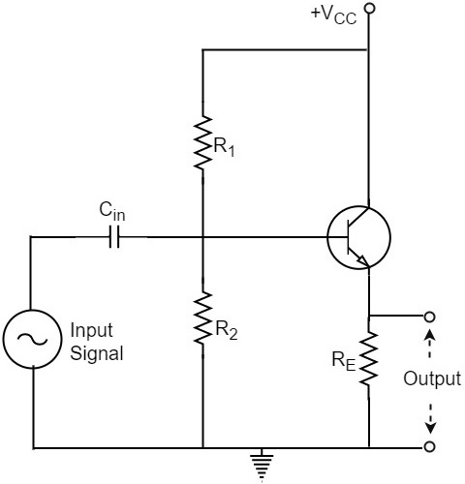

### **Operation**

The input signal voltage applied between base and emitter, develops an output voltage Vo across RE, which is in the emitter section. Therefore,

Vo=IEREVo=IERE

The whole of this output current is applied to the input through feedback. Hence,

Vf=VoVf=Vo

As the output voltage developed across RL is proportional to the emitter current, this emitter follower circuit is a current feedback circuit. Hence,

β=VfVo=1β=VfVo=1

It is also noted that the input signal voltage to the transistor (= Vi) is equal to the difference of Vs and Vo i.e.,

Vi=Vs−VoVi=Vs−Vo

Hence the feedback is negative.

### **Characteristics**

The major characteristics of the emitter follower are as follows −

* No voltage gain. In fact, the voltage gain is nearly 1.
* Relatively high current gain and power gain.
* High input impedance and low output impedance.
* Input and output ac voltages are in phase.

## RC Coupled Amplifier

The constructional details of a two-stage RC coupled transistor amplifier circuit are as follows. The two stage amplifier circuit has two transistors, connected in CE configuration and a common power supply VCC is used. The potential divider network R1 and R2 and the resistor Re form the biasing and stabilization network. The emitter by-pass capacitor Ce offers a low reactance path to the signal.

The resistor RL is used as a load impedance. The input capacitor Cin present at the initial stage of the amplifier couples AC signal to the base of the transistor. The capacitor CC is the coupling capacitor that connects two stages and prevents DC interference between the stages and controls the shift of operating point. The figure below shows the circuit diagram of RC coupled amplifier.

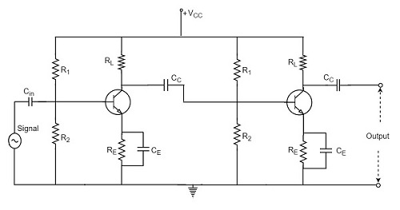

## Operation of RC Coupled Amplifier

When an AC input signal is applied to the base of first transistor, it gets amplified and appears at the collector load RL which is then passed through the coupling capacitor CC to the next stage. This becomes the input of the next stage, whose amplified output again appears across its collector load. Thus the signal is amplified in stage by stage action.

The important point that has to be noted here is that the total gain is less than the product of the gains of individual stages. This is because when a second stage is made to follow the first stage, the **effective load resistance** of the first stage is reduced due to the shunting effect of the input resistance of the second stage. Hence, in a multistage amplifier, only the gain of the last stage remains unchanged.

As we consider a two stage amplifier here, the output phase is same as input. Because the phase reversal is done two times by the two stage CE configured amplifier circuit.

## Frequency Response of RC Coupled Amplifier

Frequency response curve is a graph that indicates the relationship between voltage gain and function of frequency. The frequency response of a RC coupled amplifier is as shown in the following graph.

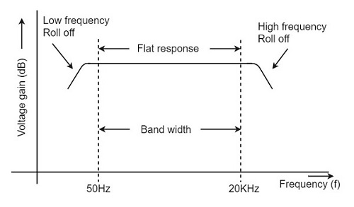

From the above graph, it is understood that the frequency rolls off or decreases for the frequencies below 50Hz and for the frequencies above 20 KHz. whereas the voltage gain for the range of frequencies between 50Hz and 20 KHz is constant.

We know that,

XC=12πfcXC=12πfc

It means that the capacitive reactance is inversely proportional to the frequency.

### **At Low frequencies (i.e. below 50 Hz)**

The capacitive reactance is inversely proportional to the frequency. At low frequencies, the reactance is quite high. The reactance of input capacitor Cin and the coupling capacitor CC are so high that only small part of the input signal is allowed. The reactance of the emitter by pass capacitor CE is also very high during low frequencies. Hence it cannot shunt the emitter resistance effectively. With all these factors, the voltage gain rolls off at low frequencies.

### **At High frequencies (i.e. above 20 KHz)**

Again considering the same point, we know that the capacitive reactance is low at high frequencies. So, a capacitor behaves as a short circuit, at high frequencies. As a result of this, the loading effect of the next stage increases, which reduces the voltage gain. Along with this, as the capacitance of emitter diode decreases, it increases the base current of the transistor due to which the current gain (β) reduces. Hence the voltage gain rolls off at high frequencies.

### **At Mid-frequencies (i.e. 50 Hz to 20 KHz)**

The voltage gain of the capacitors is maintained constant in this range of frequencies, as shown in figure. If the frequency increases, the reactance of the capacitor CC decreases which tends to increase the gain. But this lower capacitance reactive increases the loading effect of the next stage by which there is a reduction in gain.

Due to these two factors, the gain is maintained constant.

## Advantages of RC Coupled Amplifier

The following are the advantages of RC coupled amplifier.

* The frequency response of RC amplifier provides constant gain over a wide frequency range, hence most suitable for audio applications.
* The circuit is simple and has lower cost because it employs resistors and capacitors which are cheap.
* It becomes more compact with the upgrading technology.

## Disadvantages of RC Coupled Amplifier

The following are the disadvantages of RC coupled amplifier.

* The voltage and power gain are low because of the effective load resistance.
* They become noisy with age.
* Due to poor impedance matching, power transfer will be low.

## Applications of RC Coupled Amplifier

The following are the applications of RC coupled amplifier.

* They have excellent audio fidelity over a wide range of frequency.
* Widely used as Voltage amplifiers
* Due to poor impedance matching, RC coupling is rarely used in the final stages.

## Cascading of Amplifier Stages

A single stage of amplifier can provide only a limited current gain or voltage gain. Most of the applications require much higher gain. Hence, we usually use several amplifier stages connected in cascade i.e. connected such that the output of one stage becomes the input to the next stage. Thus, a multistage amplifier or cascade amplifier may provide a higher voltage gain or current gain.

Cascading of amplifier stages is usually done to increase the total gain of the amplifier. However, sometimes cascading is done to get the desired output and input impedance for specific applications. Figure 1 gives the block diagram of two-stage amplifier. The first stage is driven by a voltage source Vs having series source resistance Rs. Alternatively, the driving source may be current source Is with shunt resistance Rs. the output of the first stage is fed to the input of the second stage while the output of the second stage feeds the load impedance ZL.

Actual voltage available at the input of the first stage is Vi while V0 is the output voltage of the second stage. Then the ratio \dfrac{V_o}{V_i} forms the voltage gain of the two stage cascade amplifier. Instead of two stages as shown in figure 3, we may have three or more stages connected in cascade amplifier, it becomes possible to amplify a weak input voltage Vi of just a few microvolts to get an output voltage V0 of several volts.

[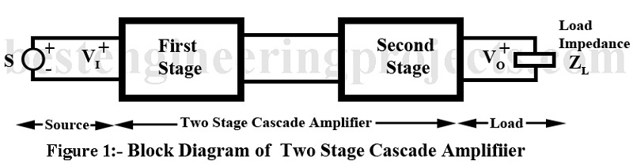](https://bestengineeringprojects.com/cascade-amplifier/)

## Cascading of Amplifier Stage using Transistor

Transistor amplifier may be connected in any of the three configurations namely [common emitter (CE)](https://bestengineeringprojects.com/analysis-of-common-emitter-amplifier-using-h-parameters/), [common base (CB)](https://bestengineeringprojects.com/analysis-of-common-base-cb-amplifier-using-h-parameter/) and [common collector (CC)](https://bestengineeringprojects.com/common-collector-amplifier-or-the-emitter-follower/). However, in cascade amplifier meant for providing high gain, only [CE amplifier](https://bestengineeringprojects.com/analysis-of-common-emitter-amplifier-using-h-parameters/) stage are connected in cascade. CB and CC configurations can not be used for this purpose.

Figure 2 gives the circuit of a two stage CE audio amplifier. The circuit gives the typical biasing arrangement and use of coupling capacitors Cb1 and Cb2. Typical values of circuit components are also given. The load impedance is a resistor while coupling is through a capacitor. Hence this cascade amplifier forms the so-called resistance – Capacitance coupled or [RC coupled amplifier](https://bestengineeringprojects.com/resistance-capacitance-coupled-or-r-c-coupled-amplifier/). Other circuit arrangement is also popular for specific uses. However, we here take up [R.C. coupled amplifier](https://bestengineeringprojects.com/resistance-capacitance-coupled-or-r-c-coupled-amplifier/) since this is the one most popularly used for audio frequency amplification. Circuit of figure 2 is given here just to give an impression as to what a typical 2-stage CE audio amplifier looks like.

[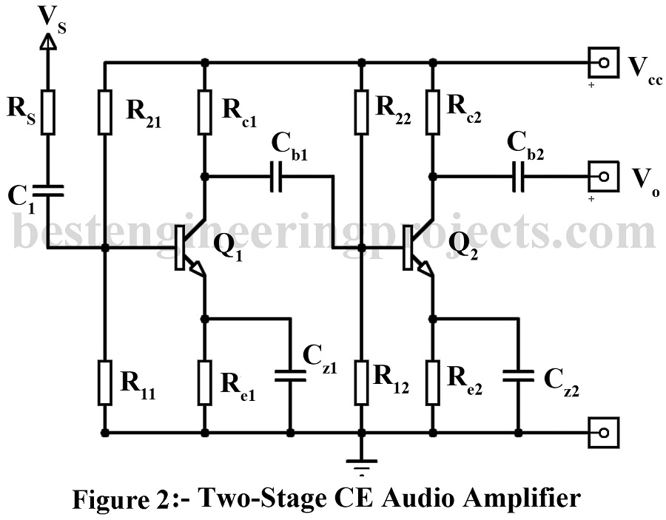](https://bestengineeringprojects.com/cascading-of-amplifier-stages/ce-audio-amplifier/)

## Analysis | Cascading of Amplifier Stages

For the purpose of analysis we take up a general n-stage CE cascade amplifier. Figure 3 gives the block diagram of the same giving the various voltages, currents and resistances involved. In Figure 3, the biasing arrangement and coupling elements have not been shown for the sake of celerity. We now proceed to derive expressions for voltage gain, current gain, power gain, input impedance and output impedance of this amplifier.

### **(A) Voltage Gain:**

The voltage gain of the complete cascade amplifier is simply the product of the voltage gains of the individual stage. This is proved below.

Voltage gain of first stage is,

A_{V1} = \dfrac{V_2}{V_1} = \dfrac{Output\ voltage\ of\ the\ first\ stage}{ Input\ voltage\ of\ the\ first\ stage } 

= A_{V1}<\theta_1       …..(1)

[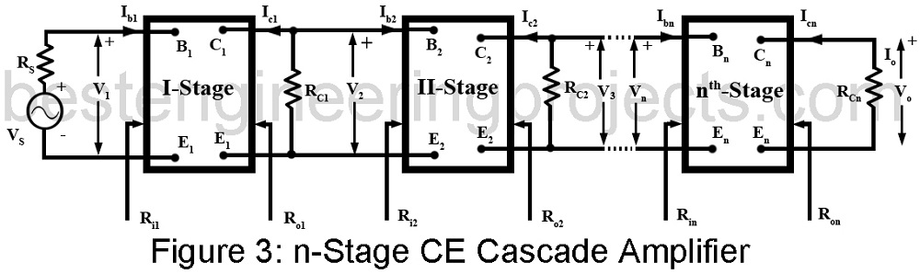](https://bestengineeringprojects.com/cascading-of-amplifier-stages/n-stage-cascade-amplifier/)

Where AV1 is the magnitude of the voltage gain and  \theta_1 is the phase angle of the output voltage V2 relative to the input voltage V1. The output voltage V2 of the first stage forms the input voltage of the second stage. Hence

Voltage gain of second stage is,

A_{V2} = \dfrac{V_3}{V_2} = \dfrac{ Output\ voltage\ of\ the\ second\ stage }{ Input\ voltage\ of\ the\ first\ stage}

= A_{V2} <\theta_2        ……(2)

Similar expressions may be written for the remaining stages.

Then the voltage gain of the complete n-stage cascade amplifier is given by,

A_V = \dfrac{V_0}{V_1} = \dfrac{ Output\ voltage\ of\ the\ n^{th}\ stage }{ Input\ voltage\ of\ the\ first\ stage }

= A_V<\theta             …..(3)

Where Av is the magnitude of the voltage gain and \theta is the phase angle of the output voltage V0 relative to the input voltage V1

But           ……(4)

From equation 4 we conclude that

A_V = A_{V1}\times A_{V2}\times A_{V3}\ .\ . \ . \ . A_{Vn-1}\times A_{Vn}        ……(5)

Or A_V <\theta = A_{V1}\times A_{V2}\times A_{V3}\ .\ . \ . \ . A_{Vn-1}\times A_{Vn}

= <\theta_1 + \theta_2 +\ .\ . \ . \ . +\theta_n          …..(6)

Hence A_V = A_{V1}\times A_{V2}\times A_{V3}\ .\ . \ . \ . A_{V2}        ……(7)

And \theta = \theta_1 + \theta_2 + \theta_3 +\ .\ . \ . \ . + \theta_n        ……(8)

From Equation (7) we conclude that the magnitude of voltage gain of the complete cascade amplifier is equal to the product of the magnitude of voltage gains of the individual stages.

From Equations 8 we conclude that the phase shift of the voltage gain of the complete cascade amplifier is equal to the sum of the phase shift of the individual stages.